**Assignment 11.1**

Write the Pig codes to analyze the petroleum data set.

DATA SET DESCRIPTION Column 1: District ID I4N 1M1 varchar Column 2: Distributor name shell varchar Column 3: Buy rate (million) $957.70 varchar Column 4: Sell rate(million) $5779.92 varchar Column 5: volume IN(million cubic litre) 933, int Column 6: volume OUT(million cubic litre) 843, int Column 7: Year 1624 int

1. What is the total amount of petrol in volume sold by every distributor?

2. Which are the top 10 distributors ID's for selling petrol? Also display the amount of petrol sold in volume.

3. List 10 years where consumption of petrol is more with the distributer id who sold it.

4. Find the distributer name who sold petrol in least amount.

1. What is the total amount of petrol in volume sold by every distributor?

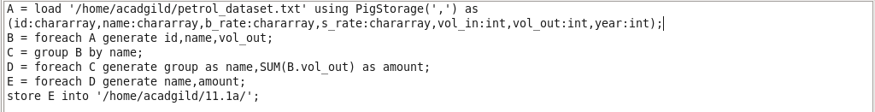

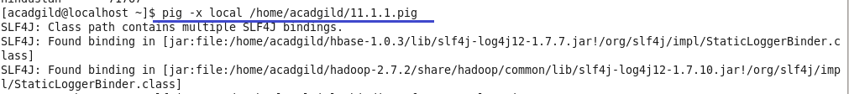

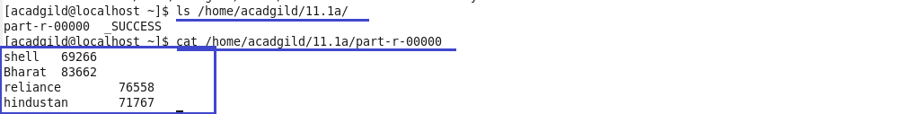

2. Which are the top 10 distributors ID's for selling petrol? Also display the amount of petrol sold in volume.

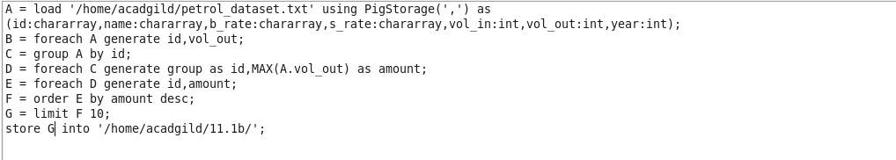

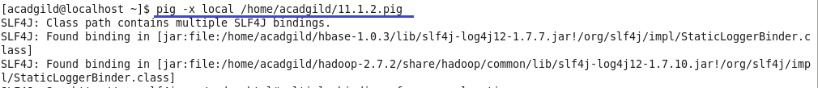

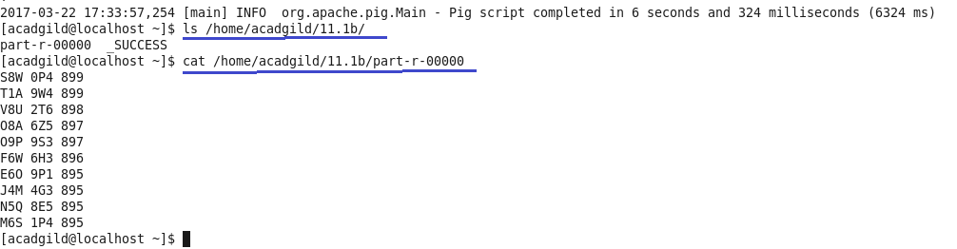

3. List 10 years where consumption of petrol is more with the distributer id who sold it.

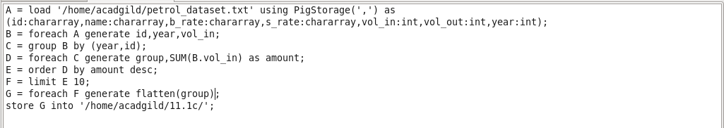

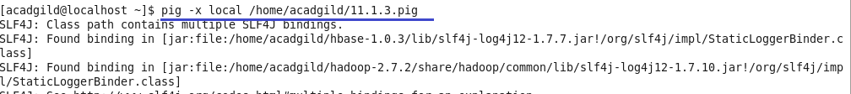

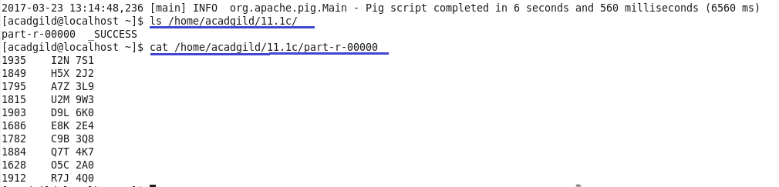

4. Find the distributer name who sold petrol in least amount.

